PAPER FORMAT

First Author¹, Second Author², Third Author³
First author’s Department, First author’s University, Address Including Country Name
first.author@gmail.com
Second author’s Department, Second author’s University, Address Including Country Name
second.author@gmail.com
Third author’s Department, Third author’s University, Address Including Country Name
third.author@gmail.com

Abstract— This document gives formatting instructions for authors preparing papers for publication in IJRRR. The authors must follow the instructions given in the document for the papers to be published. You can use this document as both an instruction set and as a template into which you can type your own text.
Keywords— Put your keywords here, keywords are separated by comma.

INTRODUCTION
This document is a template. An electronic copy can be downloaded from the conference website. For questions on paper guidelines, please contact the conference publications committee as indicated on the conference website. Information about final paper submission is available from the conference website. The text must be in English. Plagiarism is strictly unacceptable. The submitted typeset scripts of each contribution must be in their final form and of good appearance.
All paragraphs must be indented. All paragraphs must be justified, i.e. both left-justified and right- justified and have line spacing of 1.15.
- Text Font of Entire Document
The entire document should be in Times New Roman.

Recommended font sizes are shown in Table 1.
- Title and Author Details
Title must be in 18 pt Regular font. Author name must be in 12 pt Regular font. Author affiliation must be in 11 pt Italic. Email address must be in 10 pt.
TABLE I
Font Size for Paper
Font Size | Appearance (in Times New Roman )
Font Size | Regular | Bold | Italic
10 | reference item, figure caption | author email,  abstract body,  keyword body,  Text inside Table | abstract heading,  keyword (also in Bold),  reference item (partial)
11 | Level -1 Heading (in uppercase Letters with Roman Serial Number)  Paragraph Text with Line  Spacing of | Fields inside table like Font Size, Regular as shown in TABLE I | author affiliation,  Sub-heading, (Sub heading should be in capital letters  with serial number as A,  B ,C, D. )
1.15 and must be Justify, table caption
(in Small Caps),
All title and author details must be in single-column format and must be centered. Every word in a title must be capitalized except for short minor words such as “a”, “an”, “and”, “as”, “at”, “by”, “for”, “from”,
“if”, “in”, “into”, “on”, “or”, “of”, “the”, “to”, “with”. Each affiliation must include, at the very least, the name of the company and the name of the country
where the author is based (e.g. xyz, Japan).
Email address is compulsory for the corresponding author.
- Figures
Figures must be centered in the column. Large figures and tables may span across both columns. Any table or figure that takes up more than 1 column width must be positioned either at the top or at the bottom of the page.
Graphics may be full color. Graphics must not use stipple fill patterns because they may not be reproduced properly. Please use only SOLID FILL colors which contrast well both on screen and on a black-and-white hardcopy, as shown in Fig. 1.
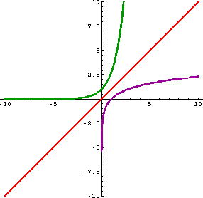
Fig. 1 A sample line graph using colors which contrast well both on screen and on a black-and-white hardcopy
Fig. 2 shows an example of an image with adequate resolution. Check that the resolution is adequate to reveal the important detail in the figure.
Please check all figures in your paper both on screen and on a black-and-white hardcopy. When you check your paper on a black-and-white hardcopy, please ensure that:
  - the colors used in each figure contrast well,
  - the image used in each figure is clear,
  - all text labels in each figure are legible.
- Figure Captions
Figures must be numbered using Arabic numerals. Figure captions must be in 10 pt Regular font. Captions of a single line (e.g. Fig. 2) must be centered whereas multi-line captions must be justified (e.g. Fig. 1). Captions with figure numbers must be placed after their associated figures, as shown in Fig. 1.
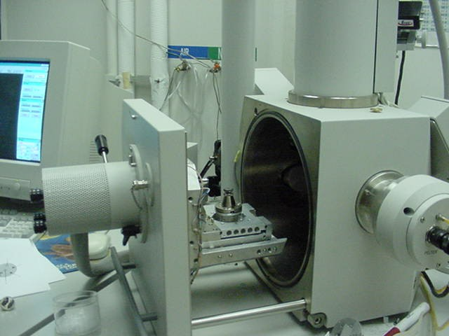
Fig. 2 Example of an image with acceptable resolution
- Table and TableCaptions
Tables must be centered in the column. The text in the table is in size of 10 pt.
Table captions must be centred and in 11 pt Regular font with numbered using uppercase Roman numerals. Table numbers must be placed before their associated tables, as shown in Table 1.
- Page Numbers, Headers and Footers
Page numbers, headers and footers must not be used.

IV Conclusions
The better you write your paper, the better the Journal looks. Thanks for your cooperation and contribution. This is the acceptable format.
V Acknowledgment
The heading of the Acknowledgment section and the References section must not be numbered.
Causal Productions wishes to acknowledge Michael Shell and other contributors for developing and maintaining the IEEE LaTeX style files which have been used in the preparation of this template. To see the list of contributors, please refer to the top of file IEEETran.cls in the IEEE LaTeX distribution

V REFERENCES
The heading of the References section must not be numbered. All reference items must be in 9 pt font. Please use Regular and Italic styles to distinguish different fields as shown in the References section. Number the reference items consecutively in square brackets (e.g. [1]).
When referring to a reference item, please simply use the reference number, as in [2]. Do not use “Ref.
[3]” or “Reference [3]” except at the beginning of a sentence, e.g. “Reference [3] shows …”. Multiple references are each numbered with separate brackets (e.g. [2], [3], [4]–[6]).
Examples of reference items of different categories shown in the References section include:
- example of a book in [1]
- example of a book in a series in [2]
- example of a journal article in [3]
- example of a conference paper in [4]
- example of a patent in [5]
- example of a website in [6]
- example of a web page in [7]
- example of a databook as a manual in [8]
- example of a datasheet in [9]
- example of a master’s thesis in [10]
- example of a technical report in [11]

- M. Metev and V. P. Veiko, Laser Assisted Microtechnology, 2nd ed., R. M. Osgood, Jr., Ed. Berlin, Germany: Springer-Verlag, 1998.
- J. Breckling, Ed., The Analysis of Directional Time Series: Applications to Wind Speed and Direction, ser. Lecture Notes in Statistics. Berlin, Germany: Springer, 1989, vol. 61.
- S. Zhang, C. Zhu, J. K. O. Sin, and P. K. T. Mok, “A novel ultrathin elevated channel low-temperature poly-Si TFT,” IEEE Electron Device Lett., vol. 20, pp. 569–571, Nov. 1999.
- M. Wegmuller, J. P. von der Weid, P. Oberson, and N. Gisin, “High resolution fiber distributed measurements with coherent OFDR,” in Proc. MEPCON19-21 Dec. 2006, pp. 109-111.
- R. E. Sorace, V. S. Reinhardt, and S. A. Vaughn, “High-speed digital-to-RF converter,” U.S. Patent 5 668 842, Sept. 16, 1997.
- (2002) The IEEE website. [Online]. Available: http://www.ieee.org/
- M. Shell. (2002) IEEEtran homepage on CTAN. [Online]. Available: http://www.ctan.org/tex- archive/macros/latex/contrib/supported/IEEEtran/
- FLEXChip Signal Processor (MC68175/D), Motorola, 1996.
- “PDCA12-70 data sheet,” Opto Speed SA, Mezzovico, Switzerland.
- A. Karnik, “Performance of TCP congestion control with rate feedback: TCP/ABR and rate adaptive TCP/IP,”
M. Eng. thesis, Indian Institute of Science, Bangalore, India, Jan. 1999.
- J. Padhye, V. Firoiu, and D. Towsley, “A stochastic model of TCP Reno congestion avoidance and control,” Univ. of Massachusetts, Amherst, MA, CMPSCI Tech. Rep. 99-02, 1999.

